Instruction Manual for Digital Counter DBC-9D
Window
Cell picture
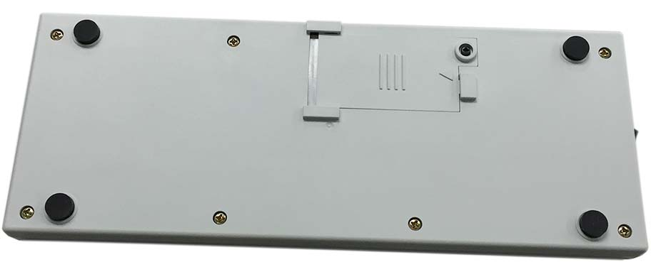
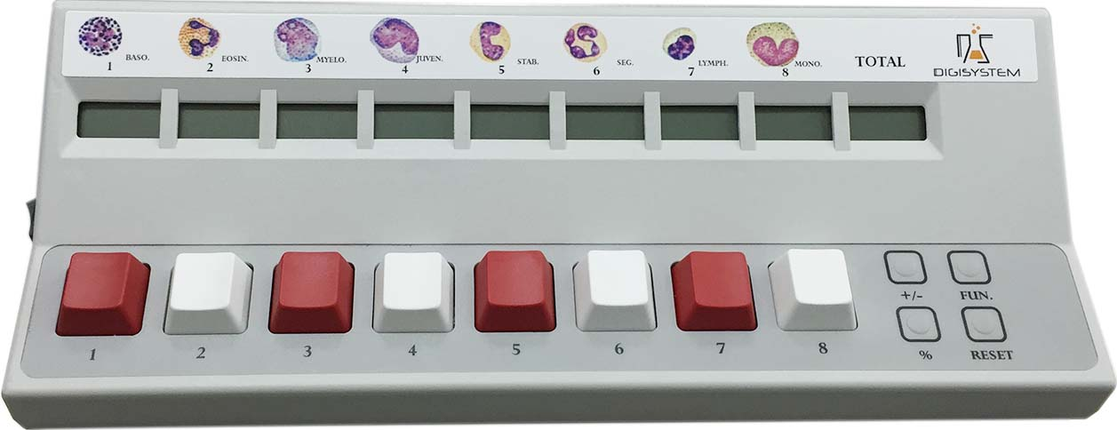
Total amount window
Battery
container
+/- button
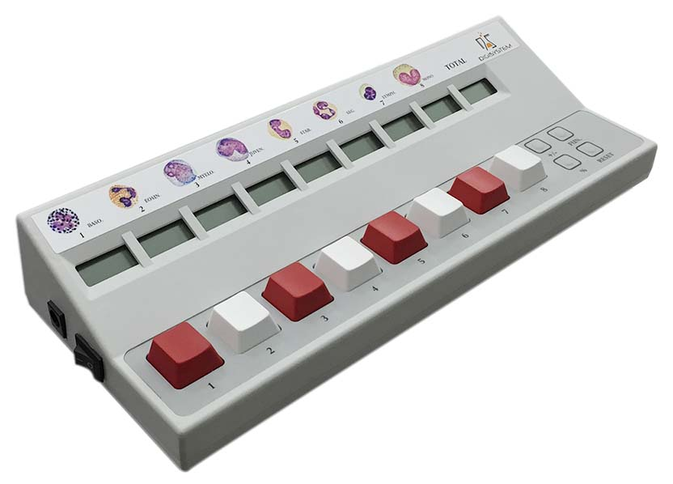
FUN. button
DC power jacket

% button
RESET button
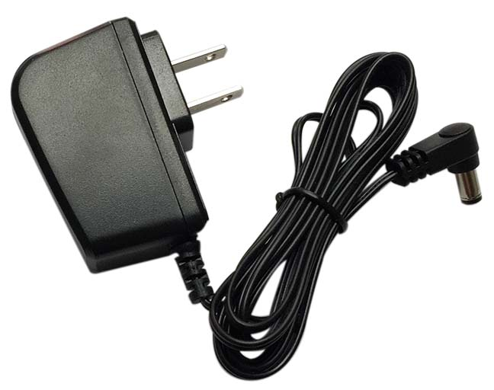
Key
Power ON/OFF switch
Switching adapter
Cautions:
1. Please use a 3.3V switching adapter. Otherwise, the unit will be damaged.
2. If using batteries, suggest using Carbon Zinc batteries.
3. For long term no use, please take out batteries.

Steps:
1. Plug the 3.3V 1.2A switching adapter into the DC power jack, and the oter end plug into a proper grounded outlet. If using batteries, please open the lid of battery cotainer, and set 2 pcs of AA battery into the battery container (please note the package doesn’t include batteries). Place the Power ON/OFF switch to ON position.
2. Push any key1 to 8 to count. Push single key at a time. Each key has a corresponding window to show the count.
3. At one hundren increment of the total amount (such as ‘100’, ‘200’, …, ‘900’), a short beep sound is heard.
4. Any window has the count up to 999, two short beep sounds are heard, and the counter stops counting.
5. If any key has not been touched for 4 minutes, a beep sound will be heard and the counter will go to the sleeping mode. By touching any key, a beep sound will be heard and the counter will go back to working mode.
6. Function buttons: when function button is pushed, a beep sound is heard.
6.1 +/- button: this function button can set the counter to be increasing (+) or decreasing (-) mode. Under decreasing (-) mode, the LCD display show below:

By touching one button, the corresponding window digit deduct one (totoal amount also deduct one). Push +/- button to go back to increasing mode.
6.2 % button: push this button to calculate the percentage. Push again to go back the original counts.
6.3 RESET button: push this button to clear the counts.
6.4 FUN. button: push this button can adjust the contrast of LCD display and monitor the battery engery.

Push key 7 to increase the contrast; Push key 8 to decrease the contrast; total window is showing battery energy. If using switching adapter, the battery energy shows 100. When battery energy is left 10, the display is sparkling. Push FUN. button again to go back to the original counts.
Maintenance and care:
Keep the counter clean all the time. Cleaning can be done with a damp cloth. Avoid the use of solvents as they may damage the product.

Circuit Diagram:
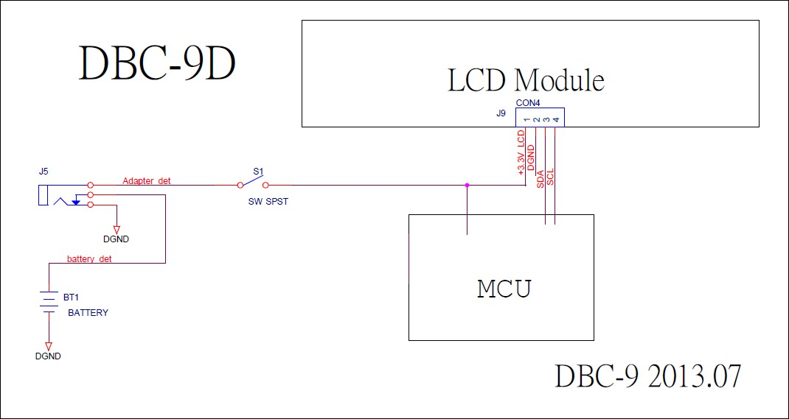

Service Manual

Troubleshooting Guide
Caution: Always disconnect the power cord before troubleshooting.
Trouble | Cause | Remedy
Instrument inoperative | Switching adapter does not connect well. | Reset switching adapter again.
Instrument inoperative | Dead power outlet. | Change to different outlet.
Instrument inoperative | Switching adapter is broken. | Replacing a new one.
Instrument inoperative | Battery energy is 0. | Replacing new batteries or use a switching adapter
Instrument inoperative | PC board is broken. | Replacing a new PC board.
Instrument inoperative | Using a wrong switching adapter and damage the PC board. | Replacing a new PC board. Please ensure use the correct switching adapter (3.3V).
Instrument inoperative | Power ON/OFF switch is not at ON position. | Placing the power ON/OFF switch to ON position.
Function buttons do not work | PC board is broken. | Replacing a new PC board.
Calculation is not correct | PC board is broken. | Replacing a new PC board.
Calculation is not correct | Pushing key way is not correct. | Push a single key at one time.

